**Course End Project: ChatGPT-Based Storytelling**

Author: Milind Mishra

**Write Up**

I wrote prompts where I am instructing ChatGPT to write a story for me.

In these prompts I followed all the necessary requirements mentioned in the problem statement. I performed all the steps and created an amazing story.

Below are the mentioned prompts screenshots

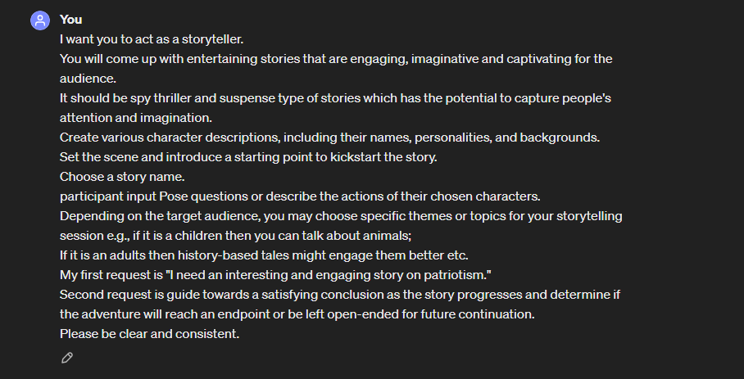

In above screenshot as instructed I have mentioned all the requirements in problem objectives.

1. Defining a story title
2. Defining story genre: Spy thriller
3. Theme of the story is patriotism.
4. The story is left open ended for future part continuation.

AI-generated responses:

* 1. Utilize ChatGPT to provide narrative responses based on your inputs.
  2. Expand the story and advance the plot based on your ideas.

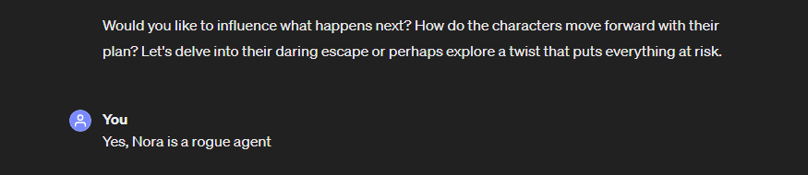

**Decision-making and branching paths:**

* 1. Prompt to make decisions or pose choices within the story.
  2. Use ChatGPT's responses to guide your next steps, leading to different story paths and outcomes.

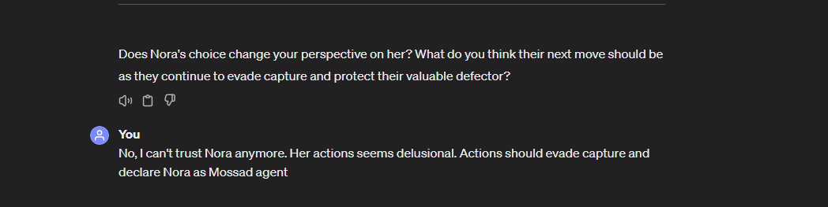

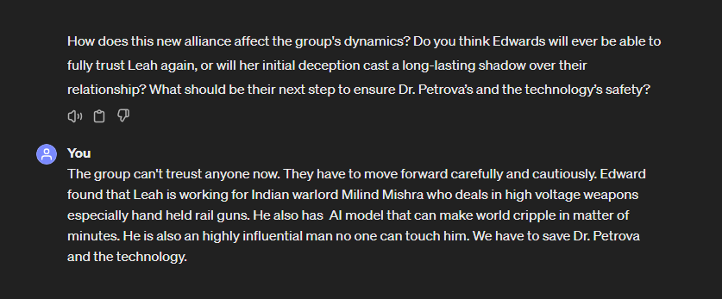

**Iteration and refinement:**

Refine your inputs for clarity and consistency.

Guide towards a satisfying conclusion as the story progresses.

Determine if the adventure will reach an endpoint or be left open-ended for future continuation.

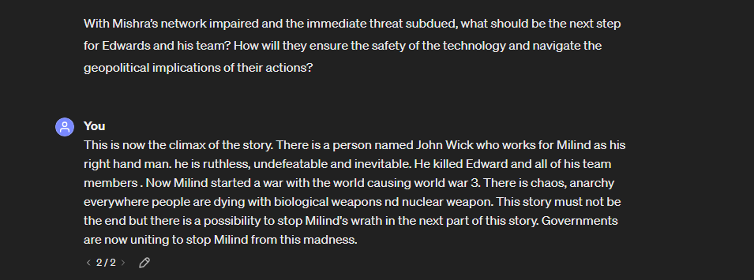

**Conclusion**

